**Logging (With Logback)**

* Logback is a reliable, fast, and flexible **logging framework** for Java supported by Apache. It's commonly used to **record application events, log debugging information for developers, and write exception events to files.**
  + It’s the replacement for its predecessor, Log4j
* **Why do we need logging?**
  + Logs record events that occur during software execution.
  + As users execute programs on the client side, the system accumulates log entries for support teams.
  + Without logs, we have a harder time determining what went wrong when an application crashes or tracking and monitoring application performance. Perhaps most importantly, you can observe potential security risks.
* Also, a logging framework like Logback is critical because it allows us to use various **logging levels** to determine which messages will be recorded in the application log files.
* Below are the Logback log levels, in order of least to most restrictive:

1. ALL => all levels (Including TRACE, which DEBUG doesn’t include)
   * 1. Note: TRACE isn’t used too much, it’s considered too verbose
2. DEBUG => designates fine-grained informational events that are most useful to debug an application. Mostly used during development.
3. **INFO** => informational messages that highlight the progress of the application.
4. **WARN** => designates potentially harmful situations
5. ERROR => designates error events that might still allow the application to continue running
6. FATAL => severe error events that presumably lead the application to abort
7. OFF => highest possible level, intended to turn off logging

* Lastly, a logger can be assigned a **threshold level**, so that all logging levels lower than the specified threshold will be ignored.
  + For example, setting the logger threshold to INFO means that logging requests with levels DEBUG will not be logged by this logger.
  + DEBUG is the default threshold level
* **To use logback, we need a maven dependency and a config file called logback.xml in our src/main/resources.**

Example logback.xml file – This one is configured to print logs in the console as well as write logs to a file that we’re calling logback.log

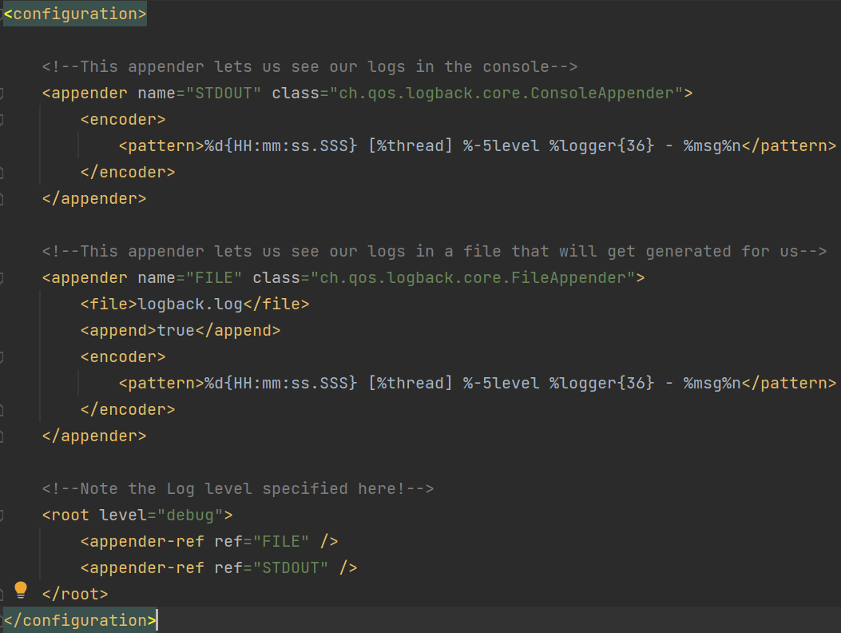  
*Please don’t try to copy this down in your own project - just steal it from our GitHub repo

Note: The logback.log file gets created automatically

* Once your configurations are in place, using Logback is easy:
* First, you need a Logger object



* Then you can use it to generate logs anywhere in your source code

